Set up cloud agent on centos:

Create activation key:

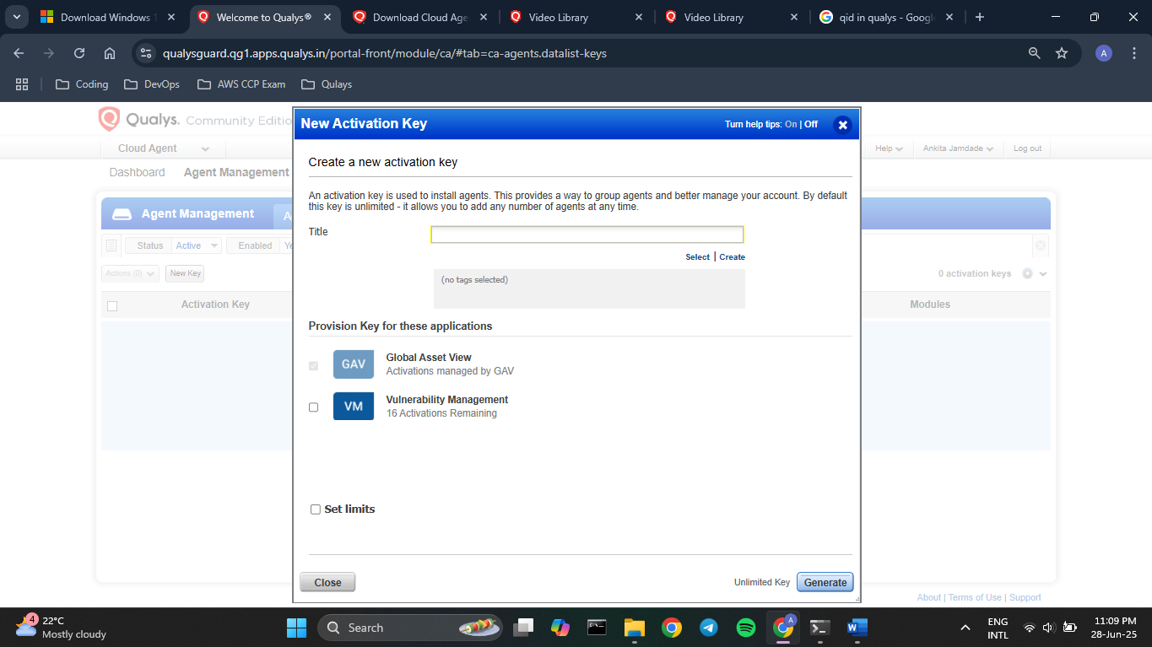

Created tag named ‘Linux VM’ so that whenever any CA is installed with this Key it’ll apply this tag to it.

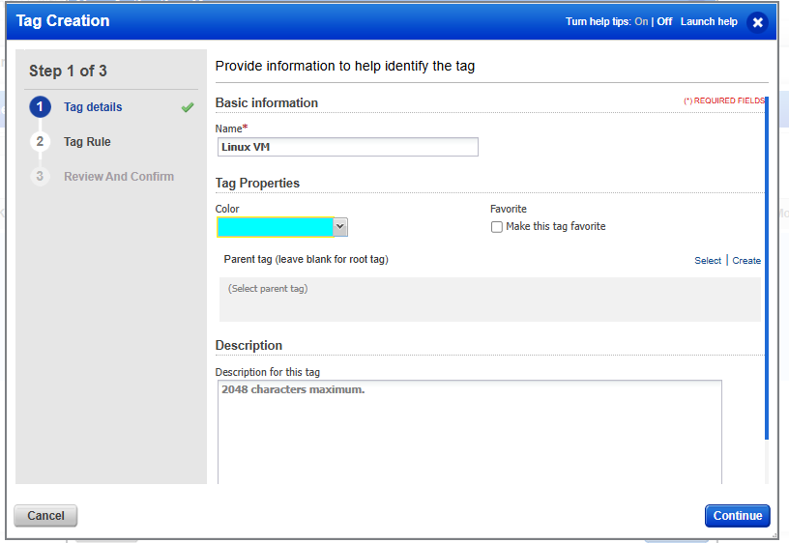



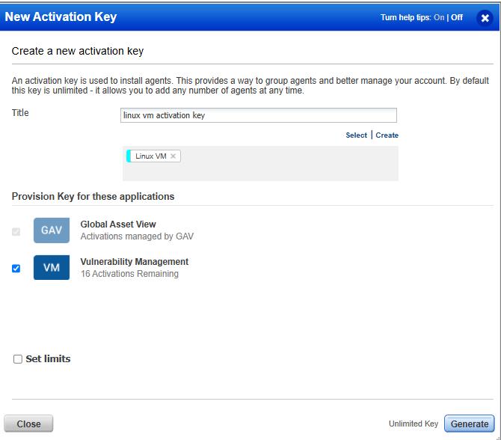

Created unlimited key. (see VM module has 16 activations available and GAV is default)

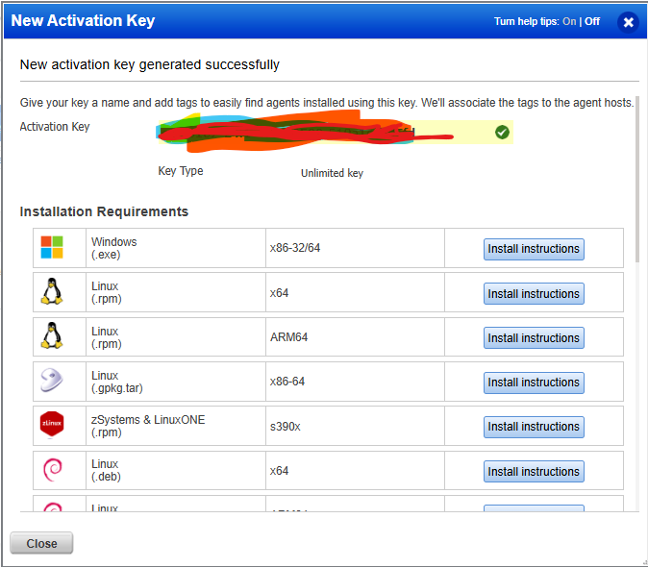

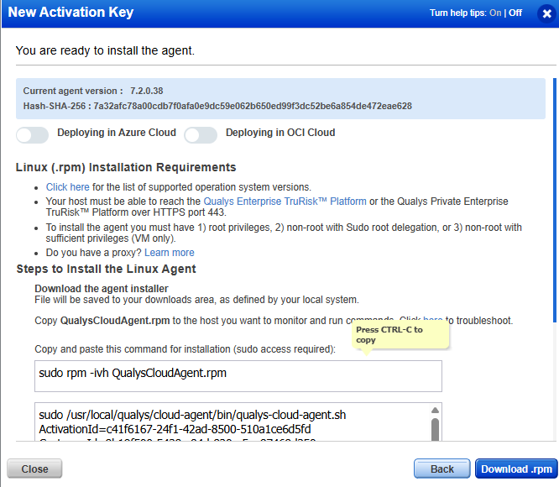

See key created:

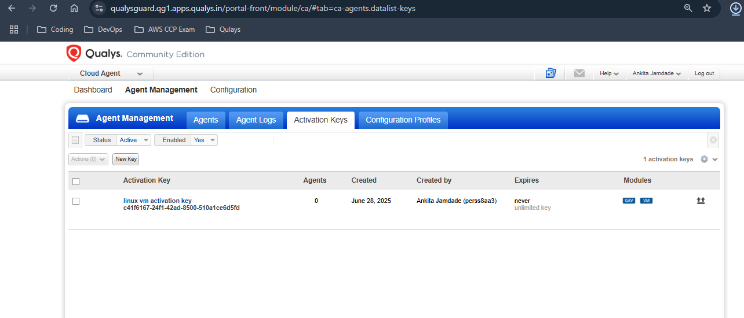

Create new conf profile:

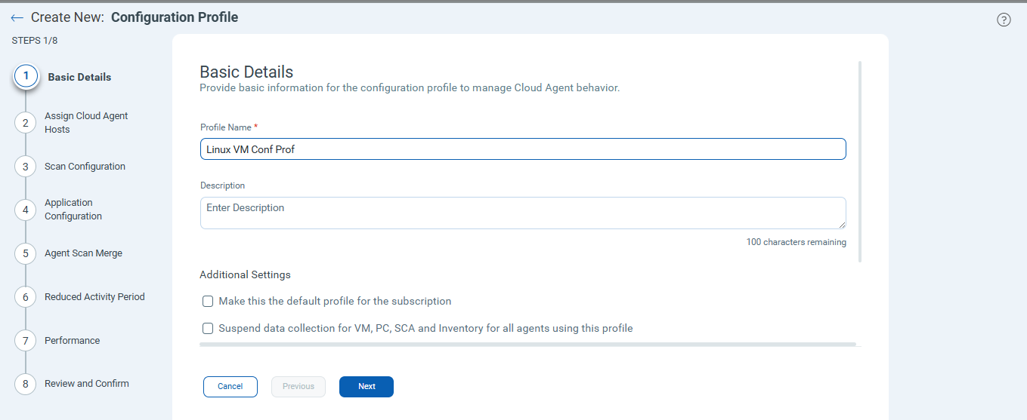

Select conf profile as per asset tag defined in act key. This’ll set profile for particular tagged assets:

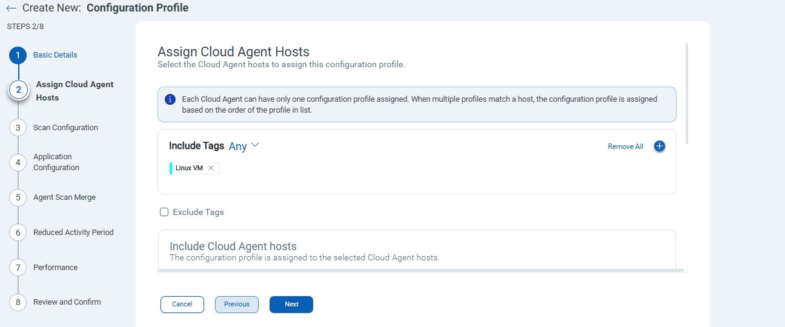

Set performance -> low

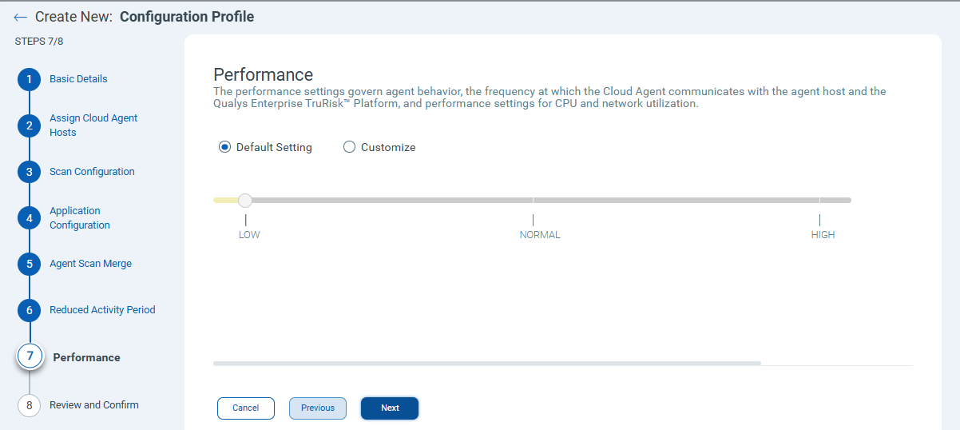

See 2 conf profiles:

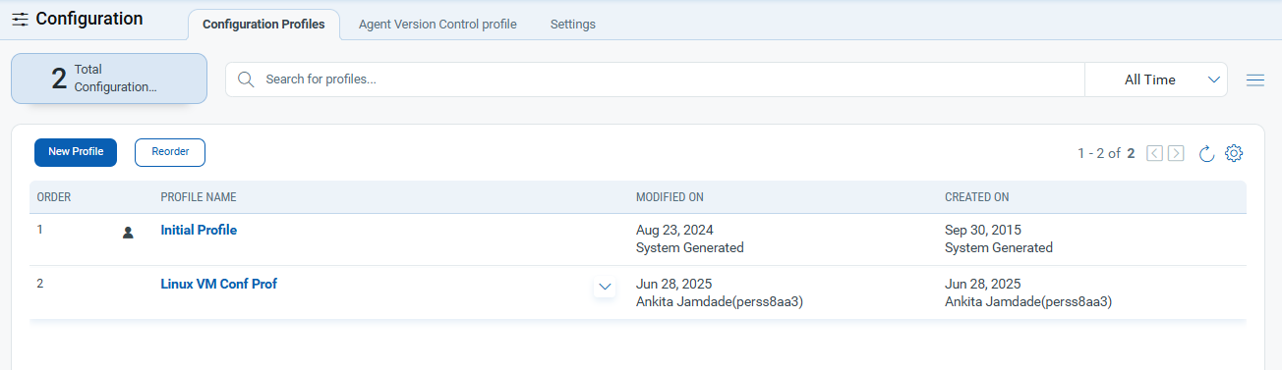

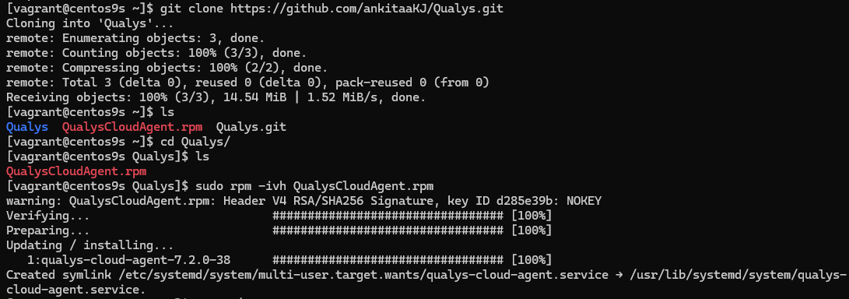



See prc ‘qualys-cloud-agent’ running with root user privileges.

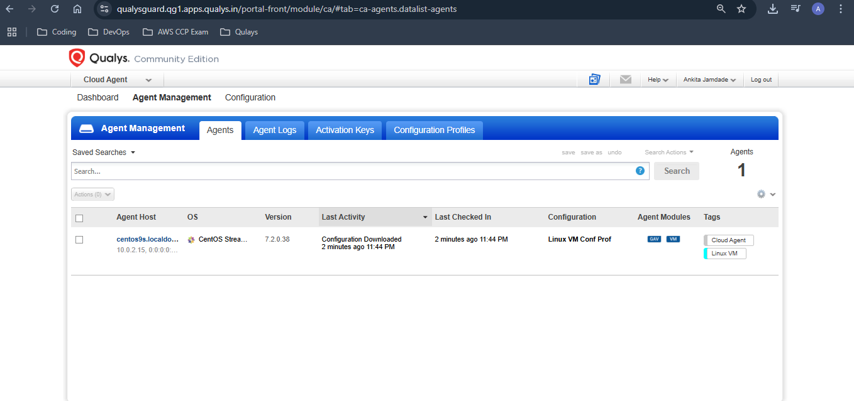

See now host has appeared in qualys agent dashboard:

